Priority queues — real-world applications and design principles
Mon, 11 May 26
Queue Data Structure Overview
- Basic principle: First In, First Out (FIFO)
- Elements added to rear, removed from front
- Real-world applications:
  - Customer call centers with waiting queues
  - Service representatives handle calls in order
Real-World Queue Examples
- Travel booking systems:
  - Train/airline tickets use waiting lists when capacity full
  - Later bookings join queue on first-come basis
  - Cancellations allow first passengers in waiting list to get seats
- Air traffic control:
  - Aircraft maintain landing queue
  - Pure FIFO insufficient due to multiple factors
  - Fuel remaining, runway distance, waiting time all influence priority
Priority Queue Concept
- Collection of objects with assigned priorities
- Insertion follows standard queue principles
- Removal based on priority, not position
  - Highest priority object removed first
  - Minimum key value = highest priority
- Addresses limitations of standard FIFO queues
- Essential for scenarios requiring urgent or special handling:
  - Senior citizens in travel booking
  - Emergency aircraft landings
  - Urgent travel needs
Next Steps
- Following video will cover efficient priority queue implementation
- Focus on heaps as primary data structure for priority queues

Heap data structure — properties, types, and operations
Mon, 11 May 26
Heap Data Structure Overview
- Binary tree-based implementation of priority queues
- Enables efficient insertion and deletion operations
- Also known as binary heaps
- Two essential properties required:
  - Relational property: defines how elements/keys are stored
  - Structural property: defines Complete binary tree shape
Heap Properties
- Relational Property:
  - Max heap: each node ≥ its children
  - Min heap: each node ≤ its children
  - Means each parent node must grater than it’s children nodes
- Structural Property:
  - Must be a complete binary tree
  - Full binary tree at height h-1 with maximum nodes
  - Remaining nodes at height h from leftmost position without gaps
- Both properties must be satisfied simultaneously
Heap Examples & Validation
- Valid heap examples:
  - Node 8 > children (6,2) ✓ relational + complete tree ✓ structural
  - Node 8 > (6,4), Node 6 > (3,5), Node 4 > 1 ✓ both properties
- Invalid heap examples:
  - Missing node creates incomplete tree (structural violation)
  - Node 4 < 5 (relational violation) + incomplete tree
  - Node 5 < 6 (relational violation) despite complete structure
  - Node 2 < 6 (relational + structural violations)
Heap Abstract Data Type (ADT)
- Members:
  - Max size: heap capacity
  - Current size: number of elements currently stored
- Core methods:
  - Insert: add element following heap properties
  - Delete max: remove and return maximum element
  - Max: return maximum element without removal
- Note: heaps are binary trees, not binary search trees
  - No left/right ordering requirements between siblings
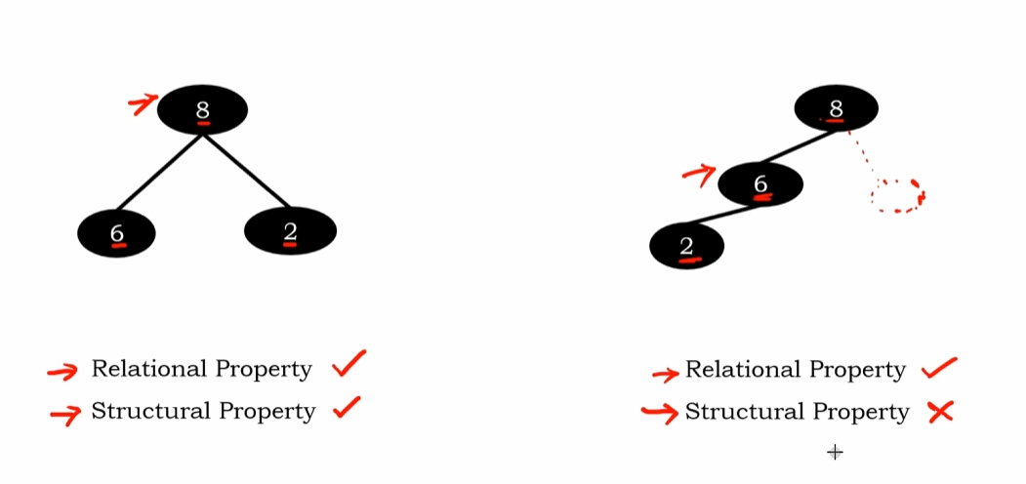
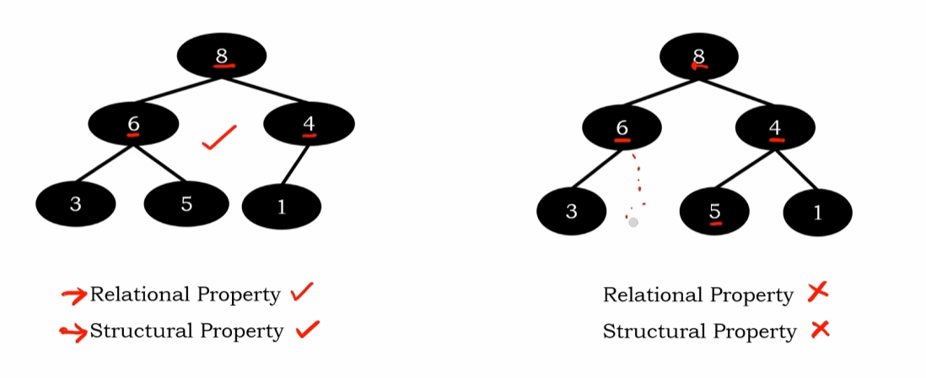
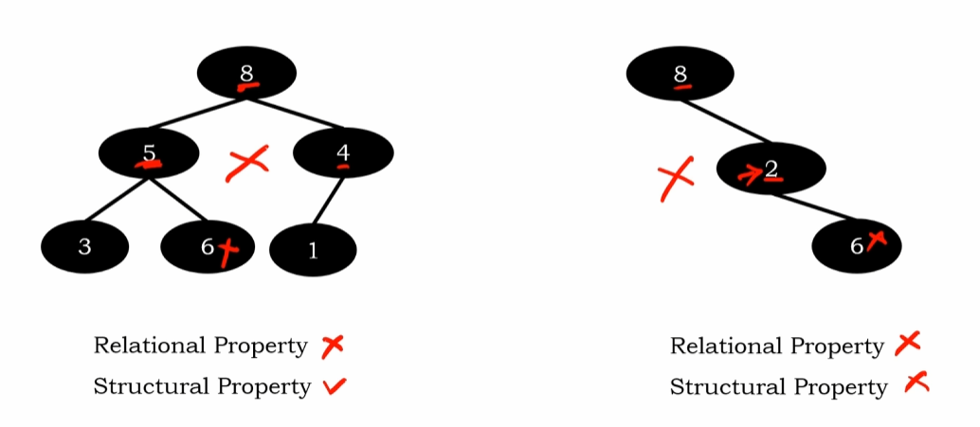

Heap insertion — structural and relational properties
Mon, 11 May 26
Heap Data Structure Overview
- Priority queues using binary trees with two key properties:
  - Relational property (max heap: parent > children)
  - Structural property (complete binary tree)
Insertion Process
- New node placement:
  - Insert after last/rightmost node in current level
  - If level full, place as leftmost node in next level
  - Maintains complete binary tree structure
- Relational property maintenance:
  - Compare new node with parent
  - If new node > parent, swap elements (upheap bubbling)
  - Continue comparisons up to root until property satisfied
Step-by-Step Example
- Initial insertions (20, 14, 2):
  - All maintain both structural and relational properties
  - 20 becomes root, 14 left child, 2 right child
- Insert 15:
  - Placed as left child of 14
  - Violates relational property (15 > 14)
  - Swap 15 and 14, check against parent 20 (satisfied)
- Insert 10:
  - Placed as right child of 15
  - No violations, no bubbling needed
- Insert 21:
  - Placed as left child of 2
  - Multiple violations require bubbling
  - 21 swaps with 2, then with 20 to become new root
Time Complexity Analysis
- Node insertion: O(1) - always insert at predetermined position
- Upheap bubbling: O(log n) worst case
  - Maximum swaps equal to tree height
  - Complete binary tree height bounded by log n
- Overall insertion complexity: O(log n)
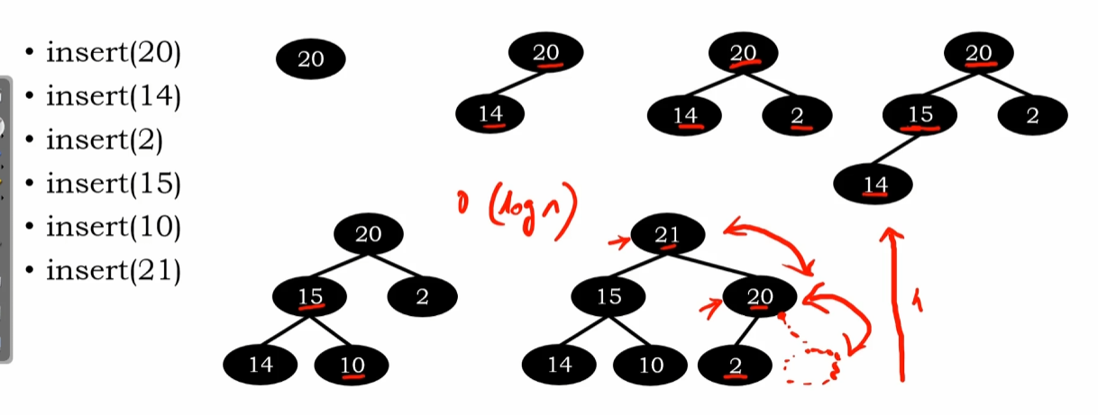

Heap insert operations — array representation and up-heap bubbling
Mon, 11 May 26
Heap Data Structure Overview
- Function to insert elements in heap using array-based binary tree representation
- Array indexed 0-7, but heap elements stored starting at index 1
- Binary tree nodes labeled in level order (root = 1, then 2, 3, etc.)
- Variables used:
  - csize: current heap size (initialized to 0)
  - hi: heap index (assigned value of csize)
Parent-Child Index Relationship
- Parent index = child index ÷ 2 (floor division)
  - Left child division gives integer
  - Right child division gives decimal, take integer part only
- Essential for heap bubbling operations
- Index 1 represents root node (no parent)
Insert Operation Process
- Increment csize, assign to hi
- Place new element at index hi
- Check relational property: element > parent
- If true, perform up-heap bubbling
- If false, insertion complete
Heap Bubbling Examples
- Element 15 insertion (index 4):
  - Parent at index 2 (value 14)
  - 15 > 14, swap required
  - Move element up to index 2
- Element 21 insertion (index 6):
  - Multiple swaps required
  - 21 > 2 (parent), then 21 > 20 (grandparent)
  - Final position: root (index 1)
Formal Algorithm Structure
- Function: heap_insert(e)
- Space check: if heap full, return “no space”
- While loop conditions:
  - Element > parent element
  - hi > 1 (not at root)
- Swap parent with child, move hi to parent index
- Insert element at final valid position

